**el 30 de octubre de 2012 español 3 - Tarea de Don Quijote**

**Tarea:** Create a ***código de armas*** to represent 1.where you are from, 2.what your family stands for, 3. areas of strength and /or success and 4. a ***dicho*** (a saying that is your motto, what you stand for such as “Live for today”)

* Use the template provided or create your own
* Color your ***código*** images
* Only write in Spanish
* Present to the class
* **Para: lunes, 5/11(B) o martes,6/11(A)**

**Modelos:** Escudo de España (mazonado)

[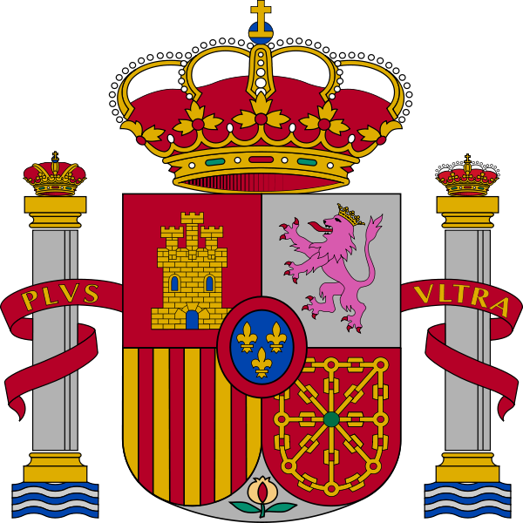](http://upload.wikimedia.org/wikipedia/commons/8/85/Escudo_de_Espa%C3%B1a_(mazonado).svg)

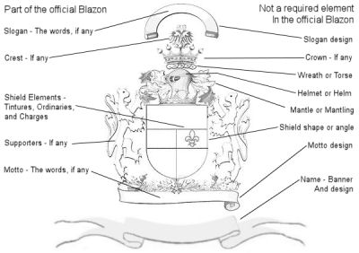

|  |  |  |
| --- | --- | --- |
|  | **Coat of Arms & Family Crests Store**   |  | | --- | | **Cervantes Family Crest / Cervantes Coat of ArmsCervantes Family Crest / Cervantes Coat of Arms**  This surname of CERVANTES was a Spanish surname of uncertain origin and meaning. It was most probably a patromynic name from a medieval given name SERVANTO, arising of a result of a cross between the Latin SERVIENS meaning 'The servant of the Lord' and SERVANDUS 'He who shall be saved'. There seems to have been some further confusion in the spelling with the Spanish CIERVO (stag). In the 8th century, Spain fell under the control of the Moors, and this influence, which lasted into the 12th century, has also left its mark on Hispanic surnames. A few names are based directly on Arabic personal names. The majority of Spanish occupational and nickname surnames, however, are based on ordinary Spanish derivatives. A notable member of the name mentions Miguel de Saavedra CERVANTES (1547-1616). He was a Spanish novelist and the author of Don Quixote. In 1569 he published his first work, a collection of pieces on the death of the Queen. He married in 1584 Catalina de Salzar y Palacios (1565-1626). The marriage was childless, but Cervantes had a illegitimate daughter Isabel de CAAVEDRA (circa 1585-1652). For 'Don Quixote' CERVANTES ranks as one of the greatest writers of the world, although it is the most carelessly written of all great books. In Spain identifying patronymics are to be found as early as the mid-9th century, but these changed with each generation, and hereditary surnames seem to have come in slightly later in Spain than in England and France. As well as the names of the traditional major saints of the Christian Church, many of the most common Spanish surnames are derived from personal names of Germanic origin. For the most part these names are characteristically Hispanic. They derive from the language of the Visigoths, who controlled Spain between the mid-5th and early 8th centuries. In the Middle Ages heraldry came into use as a practical matter. It originated in the devices used to distinguish the armoured warriors in tournament and war, and was also placed on seals as marks of identity. As far as records show, true heraldry began in the middle of the 12th | |

**Más modelos:**

[](http://www.bing.com/images/search?q=elements+coat+of+arms&view=detail&id=5655196AD5070FA019DB56CEB6EEEF26A31B3BB6&first=0&qpvt=elements+coat+of+arms&FORM=IDFRIR)[](http://www.bing.com/images/search?q=elements+coat+of+arms&view=detail&id=C97D439FBB571A8C3D509D6DFBC8D26AAE585068&first=0&qpvt=elements+coat+of+arms&FORM=IDFRIR)[](http://www.bing.com/images/search?q=elements+coat+of+arms&view=detail&id=6E79884C28C4A1D202B55062023B5CD40A15CBF3&first=31&FORM=IDFRIR)[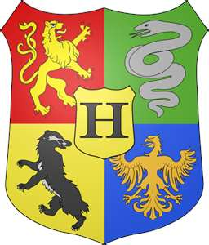](http://www.bing.com/images/search?q=elements+coat+of+arms&view=detail&id=71329C513A1EE474814C4D81ADCF511D1CF356A1&first=0&qpvt=elements+coat+of+arms&FORM=IDFRIR) [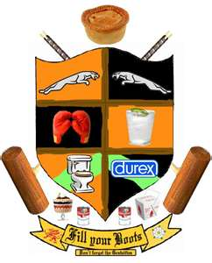](http://www.bing.com/images/search?q=elements+coat+of+arms&view=detail&id=47B1A1F60230385E9FB109B5DF219D6AB989450D&first=0&qpvt=elements+coat+of+arms&FORM=IDFRIR)[](http://www.bing.com/images/search?q=elements+coat+of+arms&view=detail&id=C630DC4F75E3B20D099F967F5BB6D33A89C45461&first=0&qpvt=elements+coat+of+arms&FORM=IDFRIR)[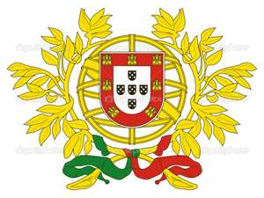](http://www.bing.com/images/search?q=elements+coat+of+arms&view=detail&id=4D7977514DB956A6BA6350332E6681EF9F176B51&first=0&qpvt=elements+coat+of+arms&FORM=IDFRIR) [](http://www.bing.com/images/search?q=elements+coat+of+arms&view=detail&id=B4D2D78DDE2FFF8CF0EFAD6361DC0934227E2BD5&first=31&FORM=IDFRIR)[](http://www.bing.com/images/search?q=elements+coat+of+arms&view=detail&id=2F1689C7507AE5DB533D35BB9588C887B5F9658B&first=31&FORM=IDFRIR)[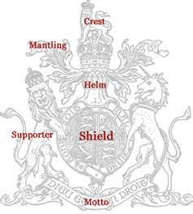](http://www.bing.com/images/search?q=elements+coat+of+arms&view=detail&id=F8F4366485123F8B78E32BF7EDDB1C97D5729632&first=0&qpvt=elements+coat+of+arms&FORM=IDFRIR)[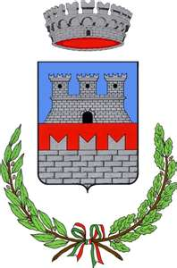](http://www.bing.com/images/search?q=elements+coat+of+arms&view=detail&id=FEA5BB4E485922E650B5EDBDA22412104A47FD2A&first=0&qpvt=elements+coat+of+arms&FORM=IDFRIR) [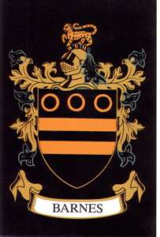](http://www.bing.com/images/search?q=elements+coat+of+arms&view=detail&id=35CFE064C5E111713647E63564BFB89A49DE983E&first=0&qpvt=elements+coat+of+arms&FORM=IDFRIR)[](http://www.bing.com/images/search?q=elements+coat+of+arms&view=detail&id=D9CFC43066AB7086E8896499B40A87E47E7EA73C&first=31&FORM=IDFRIR)[](http://www.bing.com/images/search?q=elements+coat+of+arms&view=detail&id=77A92BF4C6FDC805FE1E1197A367F90979E87687&first=31&FORM=IDFRIR)[](http://www.bing.com/images/search?q=elements+coat+of+arms&view=detail&id=9127F0697FBB2DAA08C60357E921BB03C16F8484&first=31&FORM=IDFRIR)[](http://www.bing.com/images/search?q=elements+coat+of+arms&view=detail&id=49C1B732C57AB373B0CC09FC0A0B87E55DDA8709&first=31&FORM=IDFRIR)[](http://www.bing.com/images/search?q=elements+coat+of+arms&view=detail&id=88A6DD3F28422122EDFBF9698C1113BFD0A71F15&first=31&FORM=IDFRIR)[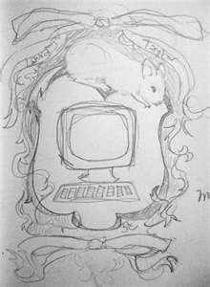](http://www.bing.com/images/search?q=elements+coat+of+arms&view=detail&id=C44C4EA5F8DFA8E62114C6AC093BA68EB3332734&first=31&FORM=IDFRIR)[](http://www.bing.com/images/search?q=elements+coat+of+arms&view=detail&id=1451C81A1202A77E089A6EC9E8E65BA6B02431C1&first=31&FORM=IDFRIR)[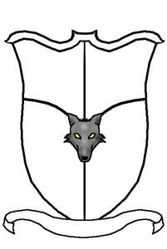](http://www.bing.com/images/search?q=elements+coat+of+arms&view=detail&id=015193448BD2B5951F800723B1B2BCC15F24A95F&first=31&FORM=IDFRIR)[](http://www.bing.com/images/search?q=elements+coat+of+arms&view=detail&id=A055B83BB08CFF4374C77669528B41CD79C04815&first=31&FORM=IDFRIR)[](http://www.bing.com/images/search?q=elements+coat+of+arms&view=detail&id=DC98DCC8C82CB020DEA7FB66ED0951F04B6384DE&first=31&FORM=IDFRIR)